ASUMBI GIRLS HIGH SCHOOL
TERM 2 – DECEMBER 2021
FORM 4 – PHYSICS PAPER 2
Marking Scheme
Section I
- a) 1.85 mA
b) 3.7 mA
2.
- Angle between the incident and the reflected rays on the second mirror
- Angle between the two mirrors
30⁰
ɵ= 60⁰
60⁰
60⁰(alternate angle)
30⁰

60⁰
3.
- metal is a good conductor of charges
- causes earthing of the electroscope
4. a) Q = It

1 mk
40 = I

1 mk
I = 20 A
b) Increased internal resistance by combining cells in series, leads to insufficient current to start the car engine
5. X – North
Y – South

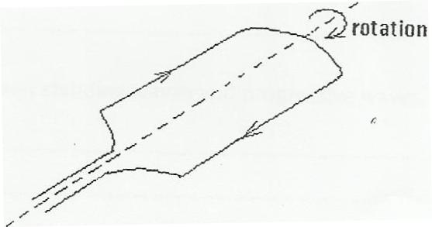
6.
Magnetic field

1 mk
7.

1 mk

1 mk
the image is virtual

8. t₂ - t₁ = 0.25
t₁ = =
= 0.588 S
^{2d} /_{v} =0.588+0.2
^{2d}/₃₄₀ =0.788 s
d=133.96
9. a)
Ultraviolet rays | X – rays
Microwaves | UV – Rays
X-rays | Visible light
Visible light | microwaves

- i) Ultraviolet rays: detect forgeries, mineral analysis, vitamin D etc
ii) Microwaves: cooking, communication
10. P =

1 mk
=

1 mk
= 9 W

11.
- do not insert foreign objects in sockets
- Do not handle electrical apparatus with wet hands
- Ensure all electrical switches are turned off when not in use

Section II
12. a) is the plane perpendicular to principal axis that passes through the principal focus
b) i) Shutter: controls the exposure of the film to light
- Film: captures and records the image
- Diaphragm: controls the amount of light entering the camera
- For the first image $\frac{1}{v}=\frac{1}{f}-\frac{1}{u} =\frac{1}{0.8}-\frac{1}{1.2} therefore v=2.4cm$
$$\frac{1}{d-2.4}=\frac{1}{2.5}-\frac{1}{10} d-2.4=3.33 d=5.733$$
- Two rays from the tip of the object to the tip of the image
- Two rays from the bottom of the object to the bottom of the image
- image

13. (a)i) It is used to cool the anode by conducting heat away
ii) Has a high melting point
(b) I. P = I X V
= 20X 10⁻³ X 100,000
= 2000W
II. I= nxe
n= I/e
= 20x10³/1.6x10⁻¹⁹
= 1,25 x10¹⁷
III. eV = KE
=
=J
( 2 mks)

- Energy =
=
=5.782eV

14. a) The ratio of the sine of the angle of incidence to the sine of the angle of refraction is constant for given pair of media
b) Due to total internal reflection
- i) ₁n₃ = ₁n₂ x ₂n₃
$\frac{3}{2}=\frac{4}{3}×$₂n₃
₂n₃ = $\frac{3}{2}×\frac{3}{4}= \frac{9}{8}=1.125$

ii) $n=\frac{\sin{i}}{\sin{r}}$
$1.125=\frac{\sin{40}}{\sin{r}}$
$\sin{r= \frac{\sin{40°}}{1.125}}$
$∴r=26.39$

1 mk
- Through successive total internal reflection

1 mk

1 mk

15. a) Charge stored per unit volt.
+ + + + + + + + + + + + + + + -
- - - - - - - - - - - - - - - - - - - - - - - -
b) i)

- Decreasing the distance between the two plates
- Using a dielectric material of higher dielectric constant
ii)

c) i) capacitors arranged in parallel

1 mk
$$C_{eff}=C_{1}+C_{2}+C_{3}$$
$=12μF+12μF+12μF$

1 mk
$$=36μF$$
ii) Capacitors in series

1 mk
$\frac{1}{C_{eff}}=\frac{1}{C_{1}}+\frac{1}{C_{2}}+\frac{1}{C_{3}}$
$= \frac{1}{12}+\frac{1}{12}+\frac{1}{12}$
$= \frac{1}{4}$

1 mk
$∴C_{eff}=4μF$

iii) Combining series and parallel
Parallel
C = 12 + 12

1 mk
= 24µF
Series
$\frac{1}{C}=\frac{1}{24}+\frac{1}{12}$
$=\frac{1}{8}$

1 mk
$∴C=8μ F$
16.a) i
I. r- beta
s- alpha
II. x…83……….
y…82……

ii) I. volatile
II. Lowers the temperature in the chamber until is super saturated
III. Radiation ionizes air inside the chamber
- alcohol droplets form on the air ions produced by the radiation forming white tracks
iv) the type of radiation can be detected , i.e can identify the nature of radiation
b)
- 6 hours
- 0.1155m
- 4 x 10⁶

